Virtusa React Training

B Sahil (221910304005)

Day 6

1. Take the input and print it, using useState.

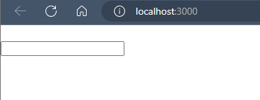

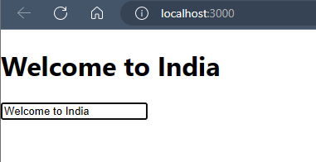

App.js

import React from 'react'

import { useState } from 'react'

export default function App() {

  const [data, setdata] = useState(null)

  function update(val){

    setdata(val.target.value)

  }

  return (

    <div>

      <h1>{data}</h1>

      <input type="text" onChange={update}/>

    </div>

  )

}

1. Print data entered after clicking “print” button.

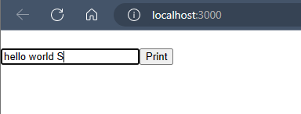

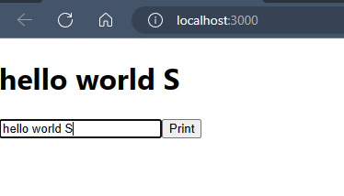

App.js

import React from 'react'

import { useState } from 'react'

export default function App() {

  const [data, setdata] = useState(null)

  const [print, setprint] = useState(null)

  function update(val){

    setdata(val.target.value)

  }

  return (

    <div>

      {print? <h1> {data}</h1>: null}

      <input type="text" onChange={update}/>

      <button onClick={()=> setprint(true)}> Print </button>

    </div>

  )

}

1. Print and data whenever required and hide whenever not.

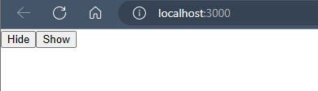

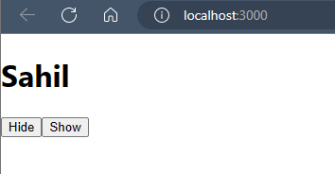

App.js

import React from "react";

function App()

{

  const[status,setStatus]=React.useState(false)

  return (

    <div className='App'>

      { status?<h1>Sahil</h1>:null }

      <button onClick={()=>setStatus(false)}>Hide</button>

      <button onClick={()=>setStatus(true)}>Show</button>

    </div>

  )

}

export default App;

Assignment:

1. Create a text field and create a button with the name "Print Your Name". Whenever, you are clicking on the button ,after clicking Your complete Name in the text field, That complete name should be displayed before the text field.

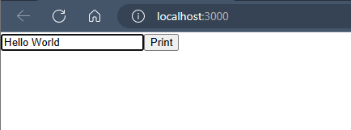

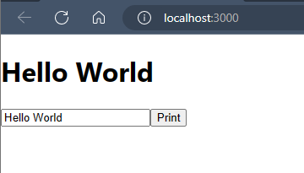

App.js

import React from 'react'

import { useState } from 'react'

export default function App() {

  const [data, setdata] = useState(null)

  const [print, setprint] = useState(false)

  function update(val){

    setdata(val.target.value)

  }

  return (

    <div>

      { print? <h1>{data}</h1> : null}

      <input type='text' onChange={update}/>

      <button onClick={()=>setprint(true)} >Print </button>

    </div>

  )

}

1. Create two buttons called as Display and conceal. If you click on display, Your Complete Name should be displayed and if click on "conceal", Your Name should disappear.

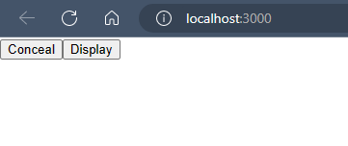

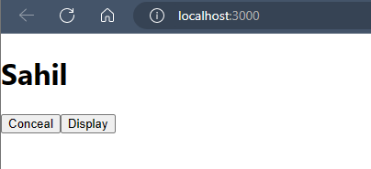

**App.js**

import React from "react";

function App()

{

  const[status,setStatus]=React.useState(false)

  return (

    <div className='App'>

      { status?<h1>Sahil</h1>:null }

      <button onClick={()=>setStatus(false)}>Conceal</button>

      <button onClick={()=>setStatus(true)}>Display </button>

    </div>

  )

}

export default App;